**Create a virtual network with 2 subnets. Each subnet should have 16 Ips only. Inside one of the subnets, create a VM and deploy an application code inside it and it should leverage the database on the cloud (any existing application created by you before)**

1. Go to portal.azure.com and select Virtual Networks

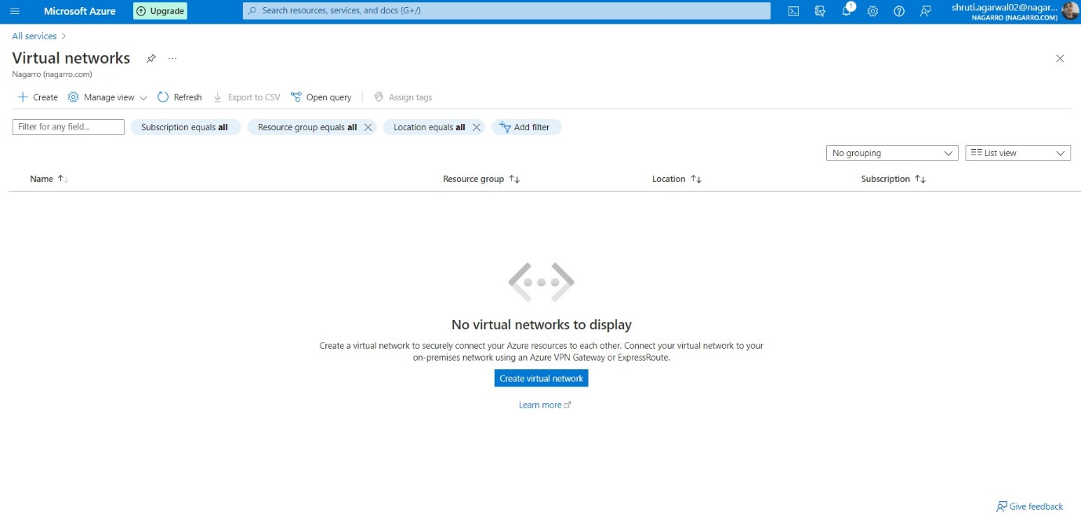

1. Then select the subscription, resource group and give the name of the virtual network and then select the region.

1. Adding 2 Subnets of 16 Ips named: Subnet_01, Subnet_02

1. Now remain the security as it is

1. Now, remain the tags as it is, if you don’t want to

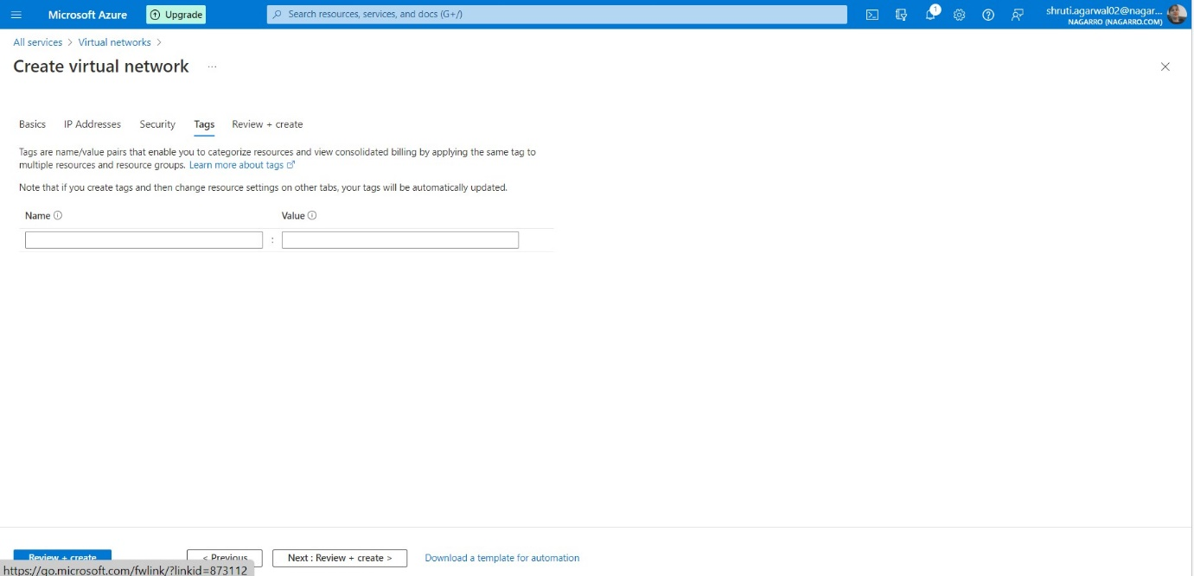

1. After that click on Create button and wait for it to get deployed

1. Now, virtual network has been create

1. Now, click on Create and fill the details of the subnet and under the Subnet address range change 10.0.0.0/24 to 10.0.0.0/28 to make the available Ips to 16 i.e., 11+ 5 reserved by azure. Do same thing to create another subnet.

1. After that click on create virtual machine and select Azure Virtual Machine

1. Then select the subscription, resource group and fill the details

1. Then for Image select Windows 10 pro and give the username and password and scroll down for further details

1. Then select the inbound ports as RDP(3389) and click the check box

1. Now, remain the disk part as it is

1. Then go to the Networking section select the Virtual Network and the Subnet for the Virtual machine to get deployed and click Review and create

1. Then click on Create button and wait for it to get deployed

1. Then click on go to resource

1. Then click on Connect and select RDP

1. Then click on Download RDP file and the click on the downloaded file

1. Then click on connect

1. Then select Use a different account

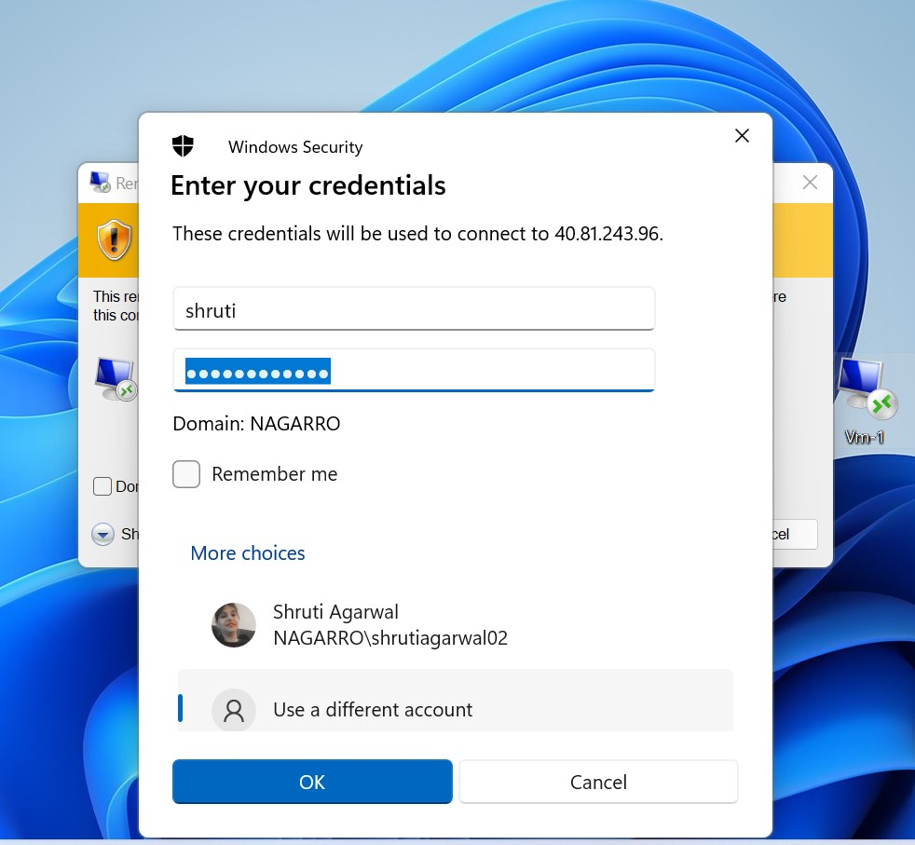

1. Then click on Yes and after that you will be moved to the virtual machine using remote desktop Connection.

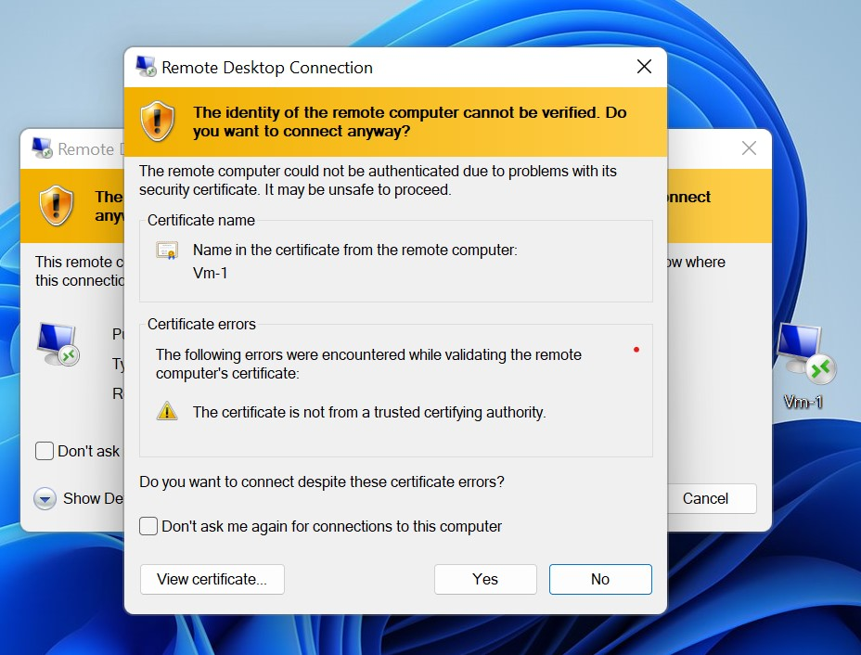

1. Now VM is started.

1. After moving to the virtual machine I have installed the jdk:18 and run the jar file of the application which is connected to the azure database.

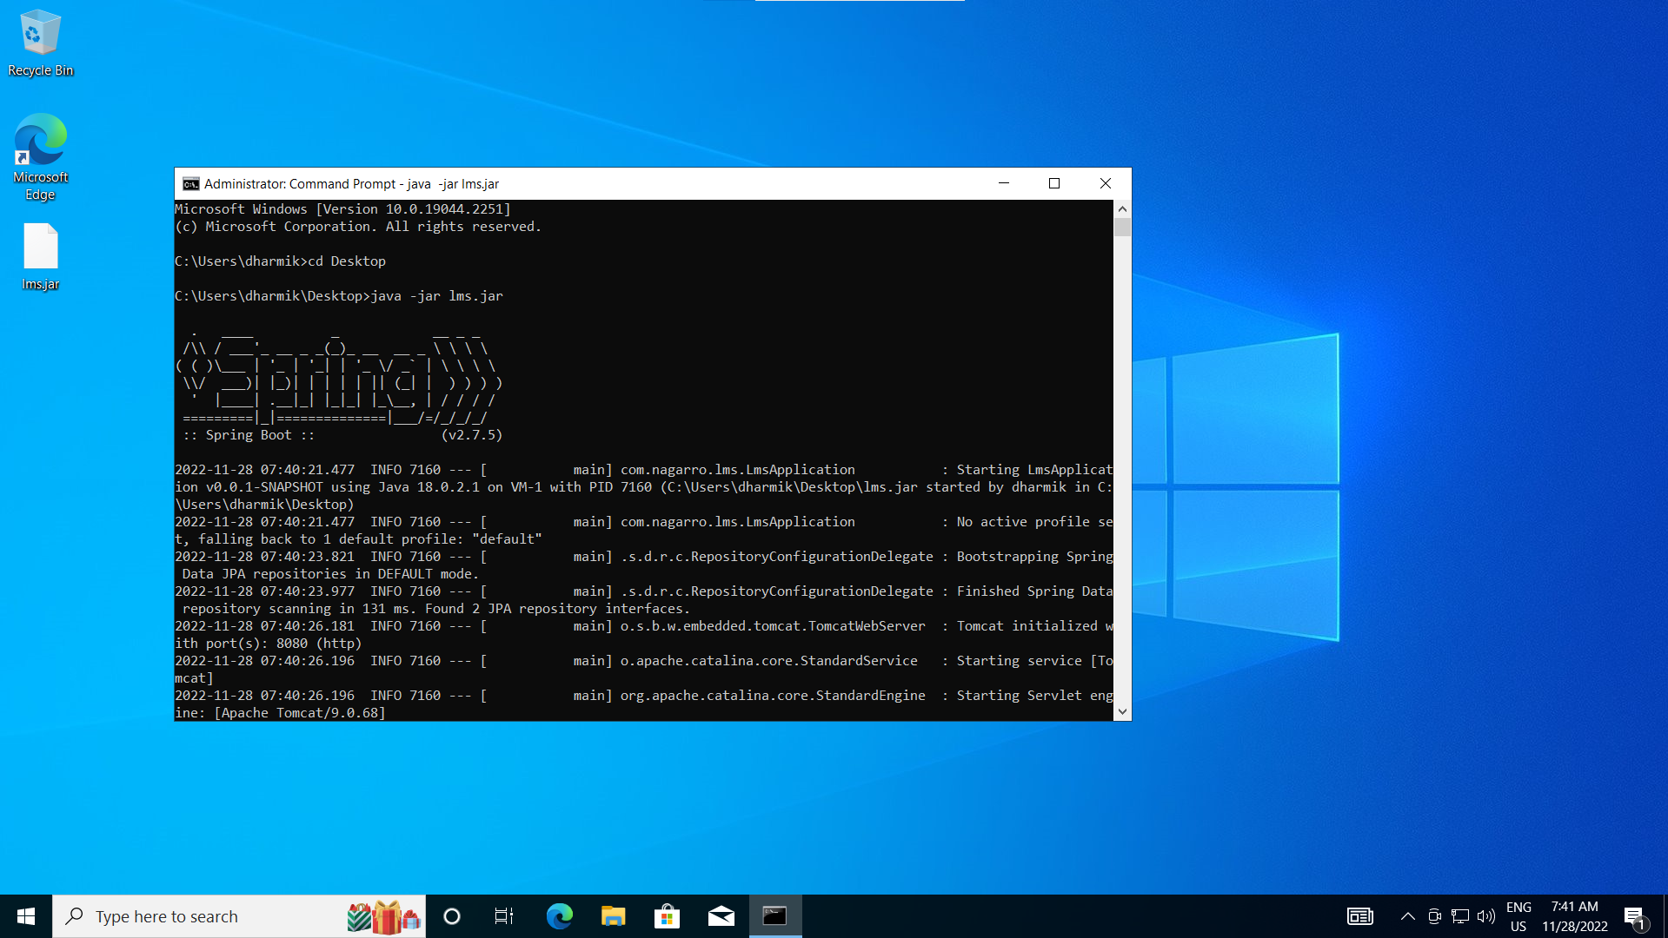

1. Output of the application after running the URL

